August 5, 2021

Hello, Waterways Commission members and officers,

In follow up to the questions raised at the June 9th meeting of the Waterways Commission regarding Ordinance 2021-0358 and the USS Orleck, I would like to share responses with you as provided by the Jacksonville Historic Naval Ship Association. As you recall, the JHNSA was unable to attend that meeting due to short notice of it being on the agenda and the Waterways Commission deferred action on this item in that meeting due to lack of information related to questions raised. I am expecting the JHNSA will be in attendance on August 11th to further address any questions you may have.

* What more precisely are the mooring plans and how are they engineered to address any casualty, especially hurricanes.

A study was conducted by SDR Analytics & Maritime, PLLC to identify and design the optimum “heavy weather” mooring plan. It’s a British/UK, OPTIMOR system. Rated for sustained winds of 84 knots and a 100 year weather event.

Ship has already survived two major hurricanes that were near direct hits:

* Laura (2020), CAT 4
* Rita (2005), CAT 5
* Maintenance schedule including removing the ship from the water for bottom painting, repairs, etc.

In drydock, she will be inspected to ensure the hull integrity can be certified for museum use for up to 10 years. Next, repair work and painting from top to bottom of the outside.  After painting she will look new again using a new advance paint formula (Juton Paint). This paint lasts longer and is easier to clean (rust will hose right off).

* What is the expected visitation count and pro forma projections for operations?

Year 1 Projected Total Visitors: post covid ~ 35,500 (General admission – 25,000, reunion and tour groups 5,000, scouts/schools 5,000, overnight campers 500).

Total annual revenue projected at more than $660,000 including museum store, memberships, special sponsorship, special events.

* Functional usability of the decks and other rooms for reunions, weddings, corporate events, etc.

From use of the flight deck, mess decks, wardroom, and berthing there are spaces onboard.

Planning for military reunions, Chief ceremonies, school field trips, overnight stays, haunted ship for Halloween, laser tag, and more! The photos below are from events actually held on the USS Orleck in Lake Charles, LA.

*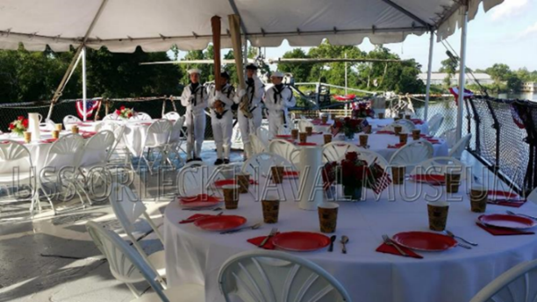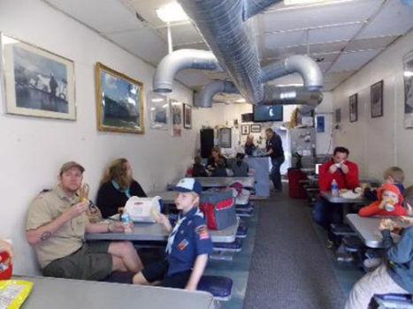*

* How will your museum operate for success from day one?

We will start with a small staff and add more staff overtime as museum programs grow.

Successful museums have a strong volunteer support, we will be no different. We already have a list who want to volunteer!

1. Staff will start small with critical positions needed first.
2. Onboard, visitors will travel topside spaces and above the ship on self-guided tours.
3. Volunteer docents will be posted at key locations on the ship for visitors to ask questions and learn from.
4. Will grow strategically as museum programs come online, grants are executed, and financial operating picture shapes.
5. An example of strategic hiring and growth:
   * General Manager (full time)
   * Assistant Manager (part time)
   * Certified Financial Professional (part time)
6. Additional hires as museum grows:

* Volunteer coordinator (part time) – this will first be a volunteer position turned future hire / staff.
* Ship Super Intendant (ship’s engineer) (part time) – this will first be a volunteer position turned future hire / staff.
* Ticketing and giftshop sales (two full, two part)
* Marketing
* What are the capabilities of Jacksonville shipyards to do the type of maintenance and repair the USS Orleck may need over time? Why were the Jacksonville shipyards not chosen to do the rehabilitation work?

This ship needs to reach the shortest distance drydock due to USCG certifications for tow. The drydock in Texas is only a 16-hour tow at most from Lake Charles, LA. Drydock may be a 3-6 week period. Tow to Jacksonville is 10 – 12 days.

The ship preservation and painting will be completed here in the future. It’s just all about timing when the drydock is available. Our drydocks remain very busy thanks to the US Navy.  This is not comparable to the maintenance requirements of Navy ships at Mayport, as those ships are underway at sea, much larger, and their maintenance cost incurs expensive engineering and computer and combat system weapons.

* Why does Lake Charles no longer want the USS Orleck?

The Orleck is moored in an industrial area that was never meant to be permanent. The city of Lake Charles, which is much smaller than Jacksonville, does not have a permanent location for her. Nearby active Navy support: None. It needs a great home! The Bold City can do that!

* Do they own it today, and have they been maintaining it on their own dime?

Yes! It was donated back from the Turkish Navy. This means the US Navy no longer owns her or has involvement.

* How can we provide confidence and assurance that this will not become an eyesore in Downtown Jacksonville and a black eye on the Navy?

There are three major naval bases within a 40-minute drive. We will have plenty of help to maintain her once she is here. A high population of retired military and veterans remain in the area.  We (JHNSA) respectfully submit that the Orleck will be much better in appearance compared to other sites currently located Downtown.

* The exit plan is a safeguard, but no one wants to see us get to that point.

We have received towing estimates for removal. Possible reef use in future. The goal is NOT to need the towing fund and to create a successful self-sustaining museum.

If Orleck is no longer viable in 10 years for another 5-10 years, we would most likely scrap and bring in a new ship. Scrapping the Orleck in 10-20 years would bring funding for the sale of the steel. This could be turned around to bring in another ship. There are other US Naval vessels that will come available in the future.

Thank you and I look forward to addressing any other questions you may have regarding this legislation.

Thank you,

Steve

Steven T. Kelley, DBA

Director of Downtown Real Estate and Development

Downtown Investment Authority